Design Pattrens:
1.Creational Design pattern:
Singleton pattern:
Logger.java(class):
package Singleton;

public class Logger {
private static Logger obj = new Logger();
private Logger() {
System.out.println("Logger object Created");
}
public static Logger getObj() {
return obj;
}
public void log(String message) {
System.out.println("LOG: " + message);
}

}
TestLogger.java(main class):
package Singleton;

public class TestLogger {

public static void main(String[] args) {
// TODO Auto-generated method stub
Logger user1 = Logger.getObj();
Logger user2 = Logger.getObj();
user1.log("Application Started");
user2.log("User Login");
System.out.println(user1 == user2);
}
}
OUTPUT:
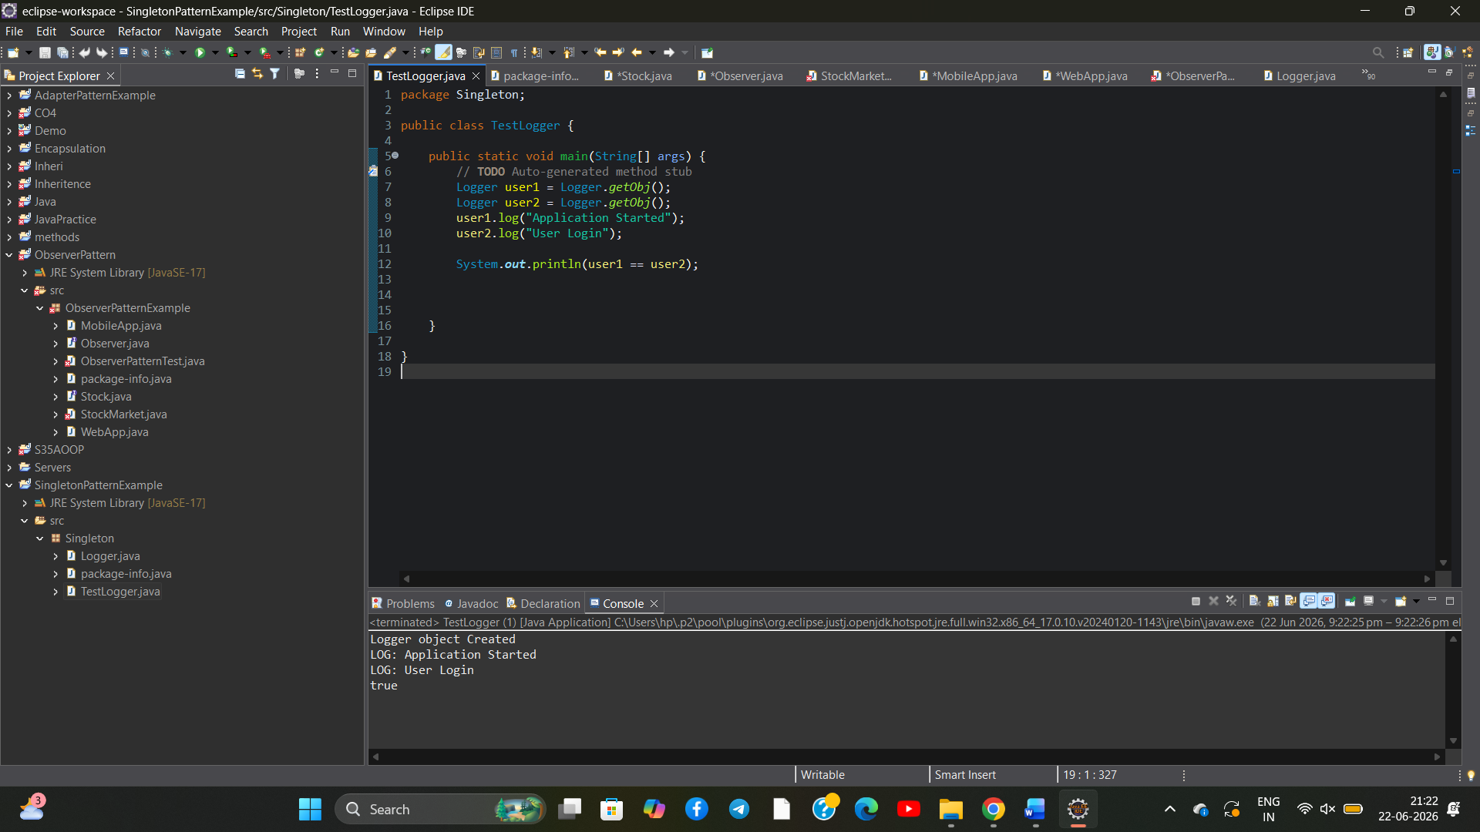
2.STRUCTURAL DESIGN PATTREN:
ADAPTER PATTERN:
1.PaymentProcessor(interface):
package com.adapterpattern;

public interface PaymentProcessor {
void processPayment(double amount);
}
2. GooglePayGateway(class):
package com.adapterpattern;

public class GooglePayGateway {

public void sendMoney(double amount) {
System.out.println("Payment of Rs." + amount + " processed through Google Pay.");
}
}
3. GooglePayAdapter(class):
package com.adapterpattern;
public class GooglePayAdapter implements PaymentProcessor {

private GooglePayGateway googlePayGateway;

public GooglePayAdapter(GooglePayGateway googlePayGateway) {
this.googlePayGateway = googlePayGateway;
}

@Override
public void processPayment(double amount) {
googlePayGateway.sendMoney(amount);
}
}
4. class PaytmGateway
package com.adapterpattern;

public class PaytmGateway {

public void makePayment(double amount) {
System.out.println("Payment of Rs." + amount + " processed through Paytm.");
}
}
5. PaytmAdapter(class):
package com.adapterpattern;

public class PaytmAdapter implements PaymentProcessor {

private PaytmGateway paytmGateway;

public PaytmAdapter(PaytmGateway paytmGateway) {
this.paytmGateway = paytmGateway;
}

@Override
public void processPayment(double amount) {
paytmGateway.makePayment(amount);
}
}
6. AdapterPatternTest(main class):
package com.adapterpattern;
public class AdapterPatternTest {

public static void main(String[] args) {

PaymentProcessor paytm =
new PaytmAdapter(new PaytmGateway());

PaymentProcessor googlePay =
new GooglePayAdapter(new GooglePayGateway());

paytm.processPayment(1000);

googlePay.processPayment(2000);
}
}

OUTPUT:
